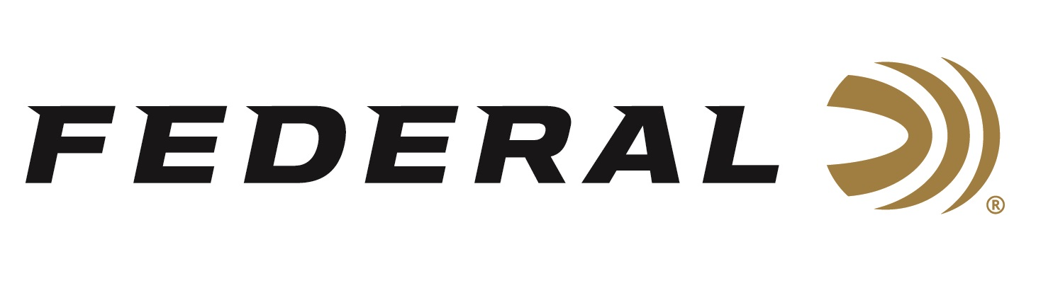

FOR IMMEDIATE RELEASE

Turkey Talk on “It’s Federal Season” Podcast

ANOKA, Minnesota – April 7, 2022 – Federal’s “It’s Federal Season” is talking turkey on the latest episode of the podcast series. Guest host Julie Golob welcomes Realtree’s Tyler Jordan to the conversation on tactics to take down a spring gobbler. The timely topic is appropriate as hunters are looking for the best remedy for cabin fever.

“Tyler is so in tune with turkey hunting,” states Golob, Federal’s Ambassador and guest host. “From sharing tips on concealment, tips on tactics to his favorite spots to hunt big tom turkeys, the host of Realtree Road Trips details it all on having a successful spring,” states Golob. Federal is a sponsor of Reatlree365, Realtree’s digital platform, that includes favorites like Realtree Road Trips and Spring Thunder.

In the popular Tech Talk segment, Golob talks with Shotshell Product Line Manager Dan Compton to discuss the different options turkey hunters have regarding ammunition selection. Compton walks through all the turkey specific ammunition options for the growing popularity of sub-gauges in Federal’s product lineup. In addition, Golob and Compton discuss the important topic of patterning prior to a first hunt of the season.

Episode #32 “Totally Turkey”
https://www.federalpremium.com/this-is-federal/podcast/

For this episode, besides listening on the Federal Premium website or Talk North podcast network, you can also subscribe to Federal Ammunition’s YouTube channel (https://www.youtube.com/user/federalpremiumammo) and tune in for the discussion.

Federal Ammunition can be found at dealers nationwide or purchased online direct from Federal. For more information on all products from Federal or to shop online, visit www.federalpremium.com.

Press Release Contact: JJ Reich
Senior Manager – Press Relations
E-mail: VistaPressroom@VistaOutdoor.com

About Federal Ammunition
Federal, headquartered in Anoka, MN, is a brand of Vista Outdoor Inc., an outdoor sports and recreation company. From humble beginnings nestled among the lakes and woods of Minnesota, Federal Ammunition has evolved into one of the world's largest producers of sporting ammunition. Beginning in 1922, founding president, Charles L. Horn, paved the way for our success. Today, Federal carries on Horn's vision for quality products and service with the next generation of outdoorsmen and women. We maintain our position as experts in the science of ammunition production. Every day we manufacture products to enhance our customers' shooting experience while partnering with the conservation organizations that protect and support our outdoor heritage. We offer thousands of options in our Federal Premium and Federal® lines-it's what makes us the most complete ammunition company in the business and provides our customers with a choice no matter their pursuit.

